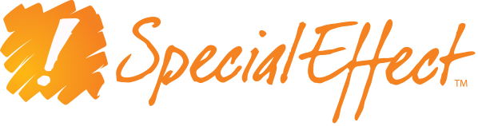

Press Release
1PM GMT 17/12/2020
From: SpecialEffect (Oxfordshire-based disability charity)

Begins:

SpecialEffect launch Eye Gaze Games, with the world’s first online multiplayer eye-controlled web games

The freely playable accessible suite of eight games makes global play possible between gamers with a huge range of abilities.

The eight browser-based games at www.eyegazegames.com - Mole Miners, 4-in-a-Row, EyeDrive, Chess, Draughts (Checkers), Solitaire and Sudoku and Sudoku Monsters - can be played using any Windows eye gaze system which offers mouse control.

“This is the first suite of online web games that enables eye gaze users to meet and play against anyone in the world, anonymously and on a level playing field,” said SpecialEffect Founder and CEO Dr Mick Donegan. “The games open up a new era of gaming inclusion for disabled players and represent a model for developers which highlights the additional enjoyment that can be gained from including gaze-control in their games.” More games will be added to the Eye Gaze Games website as they are developed.

The release of Eye Gaze Games extends the charity’s mission to help people with severe physical challenges all around the world to play video games to the best of their abilities. SpecialEffect already offers of a range of globally available resources for accessible gaming such as EyeMine, a utility for playing Minecraft with eye-control. They also provide support and advice for accessible game development, and have helped major developers such as EA, Playground Games, DoubleFine, and Rare to make games like FIFA, Day of The Tentacle, Forza Horizon and Sea of Thieves more accessible.

Ends

Assets:
- Screenshots and Ident downloadable at http://bit.ly/37lSLfS
- Download Trailer video (1:33) at http://bit.ly/3nokHoZ
- Download video of Chess being played by two women with disabilities (1:07): http://bit.ly/3oT7pRF

Contact:
Contact Mark Saville, Communications Support: mark@specialeffect.org.uk



SpecialEffect is an award-winning UK charity helping to improve the lives of disabled people across the globe through the innovative use of technology. At the core of this mission is providing greater inclusion through the opportunity to play video games to the best of their abilities.

SpecialEffect
The Stable Block, Cornbury Park, Charlbury, Oxfordshire OX7 3EH
Office: 01608 810055
info@specialeffect.org.uk
www.specialeffect.org.uk
Twitter: @specialeffect
Facebook: specialeffectcharity
Instagram: specialeffectteam

Charity no 1121004

